# Commercial Motor Vehicle Consulting

## Marketing Analysis and Research to Help Companies Plan for a Changing Environment

January 2016

CV Parts Aftermarket Leading Indicator (PLI)

**PLI Decreased 0.5% in January from December**

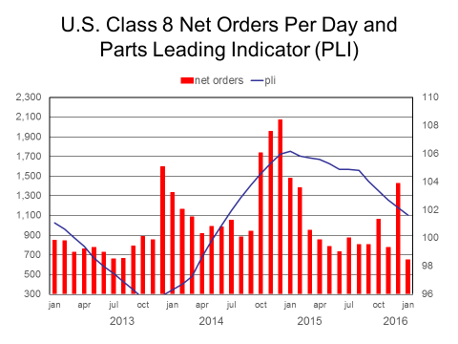Commercial Motor Vehicle Consulting (CMVC) CV Parts Aftermarket Leading Indicator (PLI) decreased 0.5% in January following a 0.6% decrease in December. PLI decreased for the sixth consecutive month, signaling the inventory correction continues to weigh on the linehaul freight environment, while local/regional freight volumes expand at sluggish to moderate growth rates. PLI remains at relatively high levels signaling fleets are not making substantial changes to operations, such as return lease vehicles early, so parts aftermarket sales will continue to be driven by vehicle demographic factors instead of cyclical factors. The decline in PLI is evident by the reduction in orders for Class 8 trucks as linehaul fleets have reduced expectations of 2016 capacity requirements as the gap between freight volumes and truck capacity decreased in 2015, as a result of a sluggish freight environment combined with moderate expansion in truck capacity. The decline in PLI during 2015 signaled lower Class 8 truck sales in 2016, but not a downturn in parts aftermarket sales, as PLI remains at relatively high levels, implying truck population depreciating at normal rates.

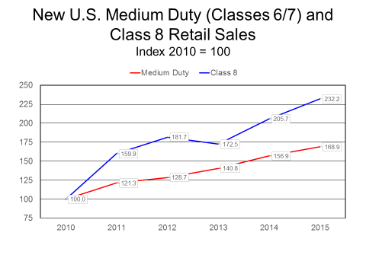

The upward trend in medium and heavy duty truck sales since the trough of the Great Recession implies an increasing number of newer model vehicles are depreciating and coming in for their first parts’ repair/replacement, such as brake drum, brake rotors, fan clutches and alternators. The decline in Class 8 truck sales in 2016 will not impact parts aftermarket sales of general maintenance parts, such as brake drums/rotors, fan clutches and alternators, due to the depreciation rate of these parts. The decline in Class 8 truck sales in 2016 will slow the growth rate of preventive maintenance parts, such as oil filters, motor oil and air filters, since these items depreciate relatively fast as reflected by short mileage intervals. The Class 8 truck population will expand in 2016, but at a slower growth rate than 2015, implying slower sales growth of high frequency parts, such as motor oil filters.

Medium duty truck sales will trend upward in 2016 due to sluggish-to-moderate growth in shipment activity and an aging truck population needs to be upgraded. This implies slightly stronger growth of high turnover parts, such as motor oil filters, and higher parts aftermarket sales of general maintenance parts, such as brake drums/rotors, as the number of newer model trucks depreciating is expanding, implying an increasing number of newer model trucks coming in for their first parts’ repair/replacement. Parts aftermarket sales are correlated with new truck sales volumes, but there is a lag in the correlation, based upon parts’ depreciation rates and this correlation is strong as long as fleet utilization is high, resulting in the truck population depreciating at normal rates. Cyclical factors overwhelm vehicle demographic factors in determining parts aftermarket sales, when there are large changes in fleet utilization (recession/recovery) results in substantial changes in fleet operations. Class 8 fleet capacity utilization has decreased, but remains at relatively high rates.

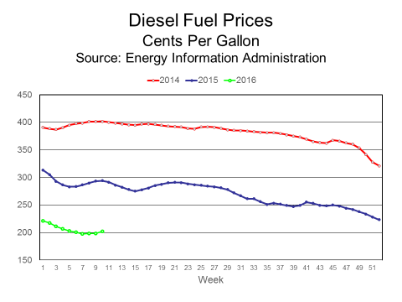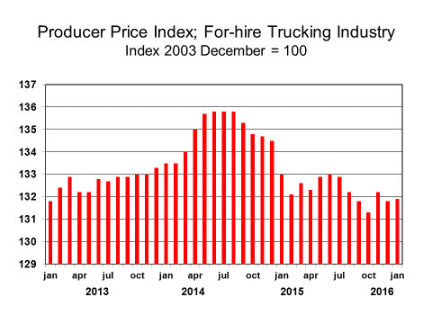The decline in Producer Price Index for the For-hire Trucking Industry does not signal a substantial decrease in truck utilization causing carriers to discount freight rates to gain market share to increase truck utilization, but rather reflects a reduction in fuel surcharges as a result of lower diesel fuel prices. The earnings reports of publicly traded for-hire carriers imply the pricing environment remains relatively stable. The decrease in the gap between freight volumes and truck capacity in 2015 implies freight rate increases excluding fuel surcharges will slow in 2016 as compared to 2015.

CMVC predicts PLI will continue to trend downward in the near term, as the inventory correction will not be completed until the beginning of the second quarter, but PLI will not decrease to low levels reflecting low fleet capacity utilization due to sluggish-to-moderate growth of local/regional freight volumes. Fleet capacity utilization will remain at relatively high levels, as a result, parts aftermarket sales will be driven by vehicle demographic factors implying higher parts aftermarket sales in 2016 in spite of lower Class 8 truck sales in 2016 from 2015.

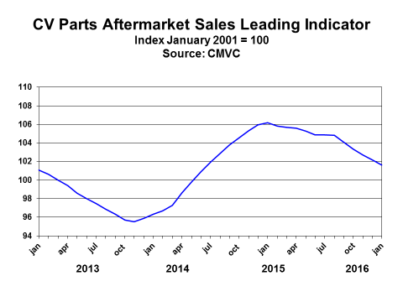

Supply Chain Factors – Freight Environment

|  |  |  |  |  |
| --- | --- | --- | --- | --- |
|  | Final Sales to Domestic Purchasers | Inventory Investment  Billions 2009 Dollars | Exports | Industrial Production |
| 2013 Q1 | 3.0% | $25.2 | 1.0% | 4.1% |
| Q2 | 1.6% | $39.6 | 4.9% | 1.9% |
| Q3 | 2.1% | $93.6 | 4.2% | 2.4% |
| Q4 | 3.8% | $87.2 | 10.9% | 4.8% |
| 2014 Q1 | 2.2% | $36.9 | -6.7% | 3.8% |
| Q2 | 4.2% | $77.1 | 9.8% | 5.6% |
| Q3 | 4.3% | $79.9 | 1.8% | 4.0% |
| Q4 | 3.9% | $78.2 | 5.4% | 4.6% |
| 2015 Q1 | 2.0% | $112.8 | -6.0% | -0.3% |
| Q2 | 3.9% | $113.5 | 5.1% | -2.3% |
| Q3 | 3.2% | $85.5 | 0.7% | 2.7% |
| Q4 | 1.7% | $81.7 | -2.7% | -3.5% |

Source: Bureau of Economic Statistics and Federal Reserve Board

The six components of CMVC’s PLI

|  |  |  |  |  |
| --- | --- | --- | --- | --- |
| Components | Month-Month Percent Change (Jan./Dec.) | Trend  Direction | Rate of Change | Trend -  Months |
| Dow Jones  Transportation Index | -10.3% | Downward | Accelerating | 2 |
| Fleet Capacity Utilization | -0.1% | Downward | Decelerating | 6 |
| Industrial Production | 0.9% | Neutral | Volatile | 1 |
| Motor Vehicle and Parts Dealers Retail Sales | 0.6% | Upward | Moderate | 3 |
| Motor Vehicle and Parts Dealers I/S Ratio | 0.00 basis pts. | Neutral | No Change | 3 |
| Producer Price Index;  For-hire Trucking Industry | 0.1% | Downward | Decelerating | 1 |

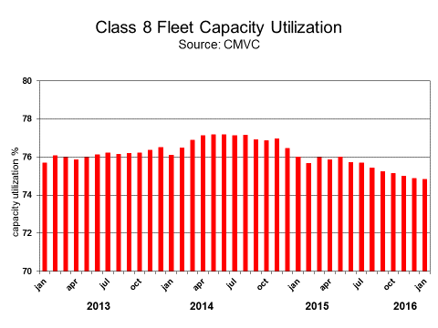

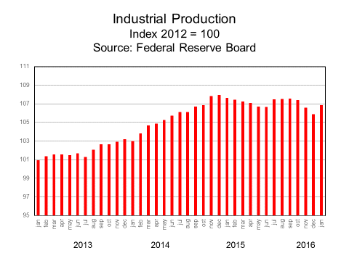

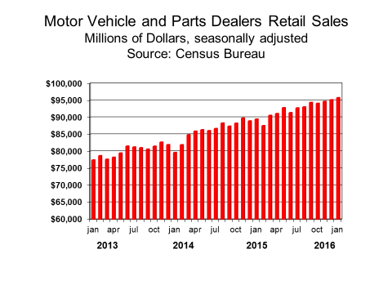

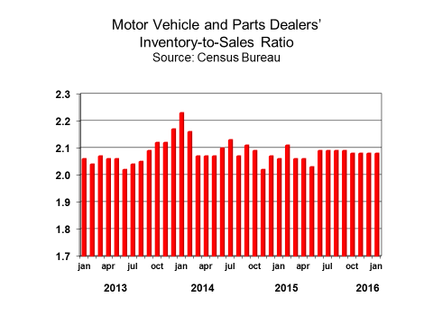

**About CMVC’s CV Parts Aftermarket Sales Leading Indictor (PLI)**

PLI was designed by CMVC to be a short-term forecasting indicator of U.S. commercial vehicle parts aftermarket sales by signaling peaks/troughs and inflection/turning points in parts sales due to changes in fleets’ business environments as a result of cyclical change in the business cycle – expansion, recession and recovery. PLI does not measure changes in trend factors, such as vehicle demographics, that have a medium and/or long-term influence on parts aftermarket sales, since changes in trend factor variables lag the fluctuation and turning points in parts sales related to changes in the business cycle when cyclical factors overwhelm trend factors. Trend factor variables are not good predictors of changes in parts aftermarket sales related to changes in fleets’ business environments. A composite index was constructed to signal fluctuations in CV parts aftermarket sales, since the contribution of one data series over time differs from parts sales, so a composite index comprised of multiple data series is a better predictor of fluctuations/turning points in parts sales as the composite index gains better predictive powers from diversification.